UX Document

This is a one page data visualization project with very few interactive options. So I’ll just demonstrate the whole page via screenshot.

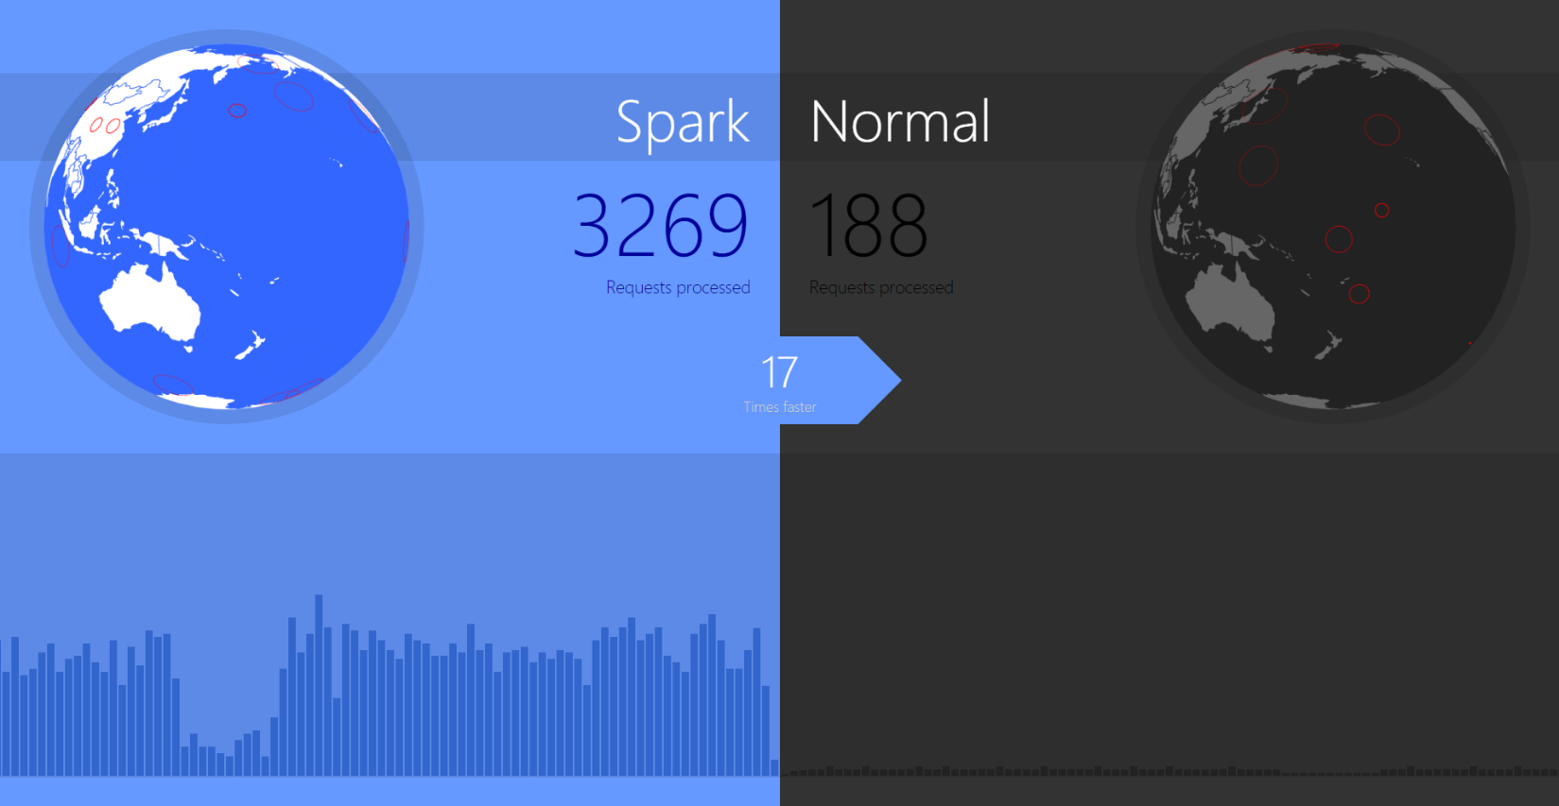

1. **Comparison**

The whole screen split into two half. The left part is the service we want to emphasize (I’m using “Spark” as the name here), and the right one is the normal one for comparison. Our demonstration is that everything on the left side is faster or more. It’s also using a brighter color to stimulate users’ positive reaction.

1. **Globe**

This is the area where user can observe the geographic information of requests. Each request being processed will create a red “ping” on the globe. And we expect that there’ll be far more “ping” on the left side while we use the real data.

1. **Requests Processed**

This is the area where user can read the real numbers of processed request amount. It’s updating in a high frequency. Because of this is an amount, so it’ll keep being more and more emphasizing when time passes.

1. **Rank Chart**

This is the area where user can observe value per second. It’s a linear bar chart keeps updating from center to the side of the screen. Currently I’m using requests processed per second as the value for the chart, eventually we may want to use the Rank.

1. **Efficiency Indicator**

This is the area where user get the conclusion of the whole page. It’s updating based on the Request Processed amounts of both sides. The ultimate goal of the page is try to tell users how “GOOD” the optimized service is, and this indicator turn that level into a real number, which makes the conclusion more intuitive and persuasive.